Record relationships

Cataloging information in Voyager is stored in 3 types of record: bibliographic, holding, and item records. The bibliographic record is the "anchor"--holdings records are linked to the bibliographic record, and in turn item records are linked to holdings records.

The bibliographic record (BIB) contains the description of the entire publication whether it consists of single or multiple volumes. The description includes author, title, and other identifying information. There is only one bibliographic record for each distinct publication.

The holdings record (MFHD, pronounced “muff-head”) contains the location, copy number, and call number. In the case of serials and booksets it also contains summary information on which volumes the library has. There will be a separate holdings record for each copy of the publication the library owns, so a bibliographic record may have more than one holdings record attached to it. Copies may be in the same location or in different locations.

The item record (ITE) represents a physical object (a volume). It contains location and circulation-related data such as loan period. In the case of serial and bookset volumes it also contains the designation that identifies a specific volume, such as volume number, date, etc. An ITE contains a single unique barcode number. There will be a separate item record for each separately bound volume, so a holdings record may have more than one item record attached to it.

NOTE: Voyager does not contain ITEs for every volume in the collection. In particular, many serials have few or no ITEs. The presence of a barcode on a volume does not necessarily mean that a corresponding ITE can be found in Voyager. In RECAP transfers many new ITEs will be created to represent volumes.

Record relationships in brief:

BIB record
Author, title, etc. Describes a publication: one volume or several volumes.

MFHD record
Location, call number, holdings. Describes a copy: one volume or several volumes.

One or more per BIB

ITE record
Barcode number, location, volume designation. Identifies a single volume.

One or more per MFHD

In Voyager, record relationships are displayed as a hierarchy. Use the far right button on the toolbar. The presence of additional ITEs is indicated by a plus sign (+) next to the MFHD. All ITEs for the MFHD can be displayed by clicking on the plus sign. When all are displayed , the plus sign becomes a minus sign. Clicking on the minus sign returns the display to the condensed format.
1 MFHD. 1 ITE.

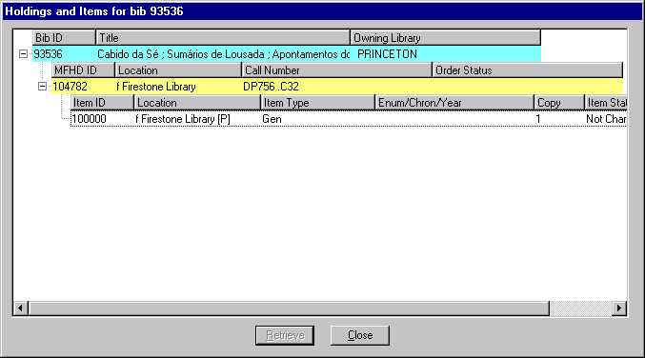
1 MFHD. 0 ITEs.

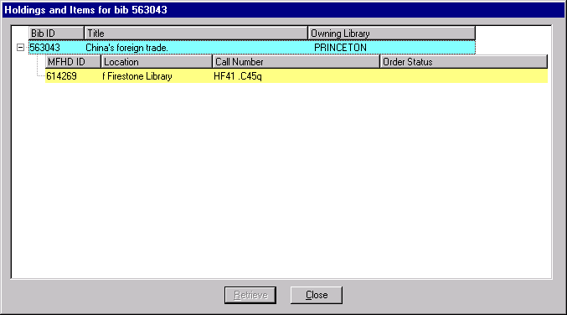
1 MFHD. 5 ITEs for volumes 1 through 5 of the bookset.

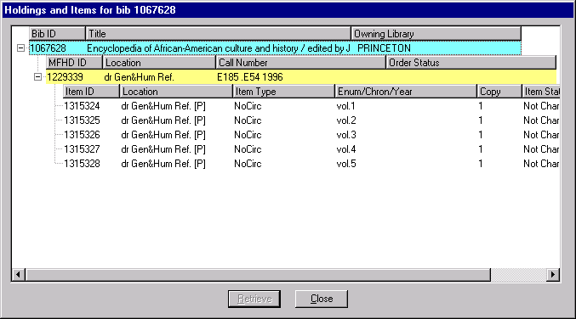
3 MFHDs. Each MFHD has a linked ITE (viewed by clicking on the plus sign).

